## Task 1 : Creating New VPC

1. Make sure you are in the US East (N. Virginia) us-east-1 Region.
2. Navigate to VPC by clicking on  on the top of AWS Console.
3. Click on VPC (under Networking & Content Delivery section) or you can also search for VPC.
4. Click on Your VPCs from the left menu.
5. Here you can see the list of all VPC, No need to do anything with the existing and default VPCs, we will create a new VPC for this lab.
6. Click on .
   * Select VPC Only
   * Name tag: Enter a VPC name for identification to your VPC. Ex: *MyVPC*
   * IPv4 CIDR block: Enter *10.0.0.0/16*
   * IPv6 CIDR block: No need to change this, make sure No IPv6 CIDR Block is checked.
   * Tenancy: No need to change this, make sure Default is selected.
   * Now click on .   
     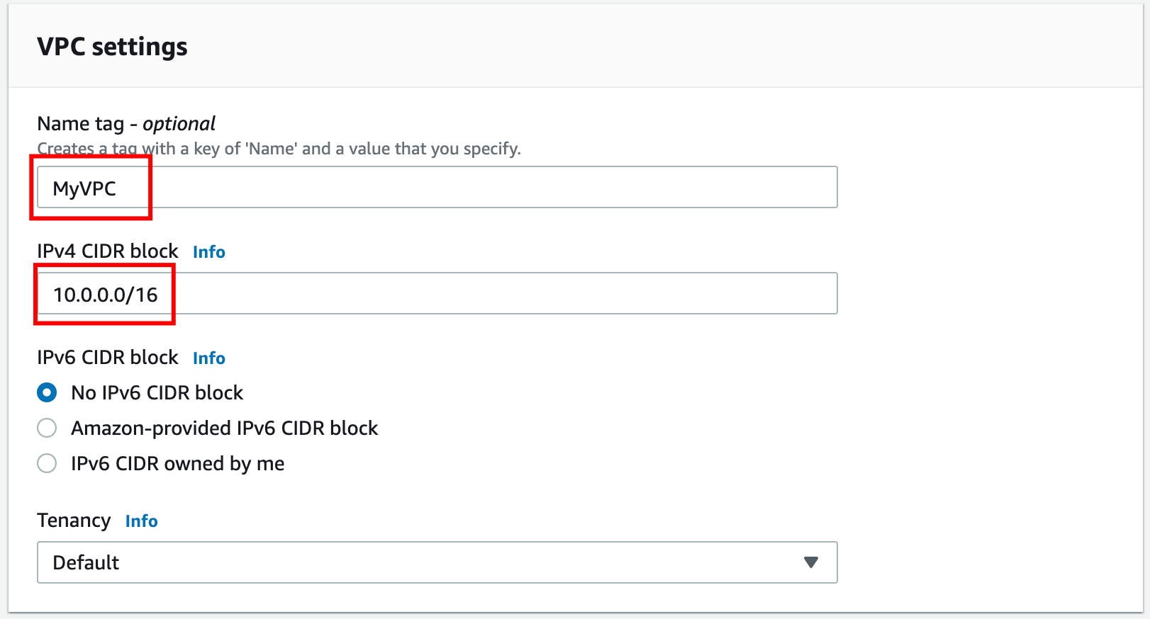
7. Once VPC is created, it will appear with details as shown below:

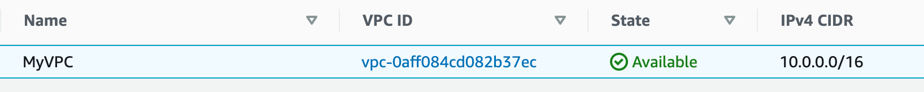

## Task 2 : Creating Subnets

In this lab, we will create one public subnet and a private subnet in us-east-1a and us-east-1b Availability Zones respectively as follows:

1. For the Public Subnet, click on Subnets from the left menu and click on 
   * VPC ID : Select MyVPC from the list you created earlier.
   * Subnet Name : Enter Name *MyPublicSubnet*
   * Availability Zone : Select us-east-1a
   * IPv4 CIDR block : Enter the range *10.0.1.0/24*
   * Click on Create subnet.
2. For the Private Subnet, click on Create subnet again.
   * VPC ID : Select MyVPC from the list you created earlier.
   * Subnet Name : Enter Name *MyPrivateSubnet*
   * Availability Zone : Select us-east-1b
   * IPv4 CIDR block : Enter the range *10.0.2.0/24*
   * Click on Create subnet.

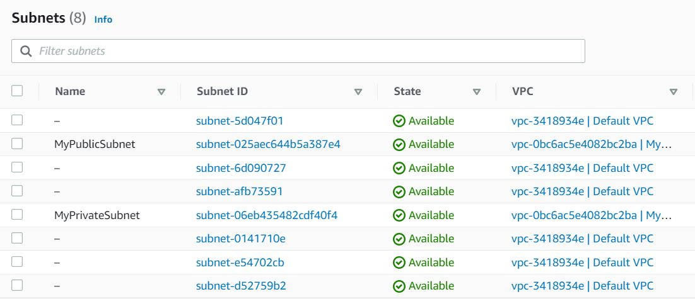

## Task 3 : Create and configure Internet Gateway

1. Click on Internet Gateways from the left menu and click .
   * Name Tag : Enter *MyInternetGateway*.
   * Click on .  
       
     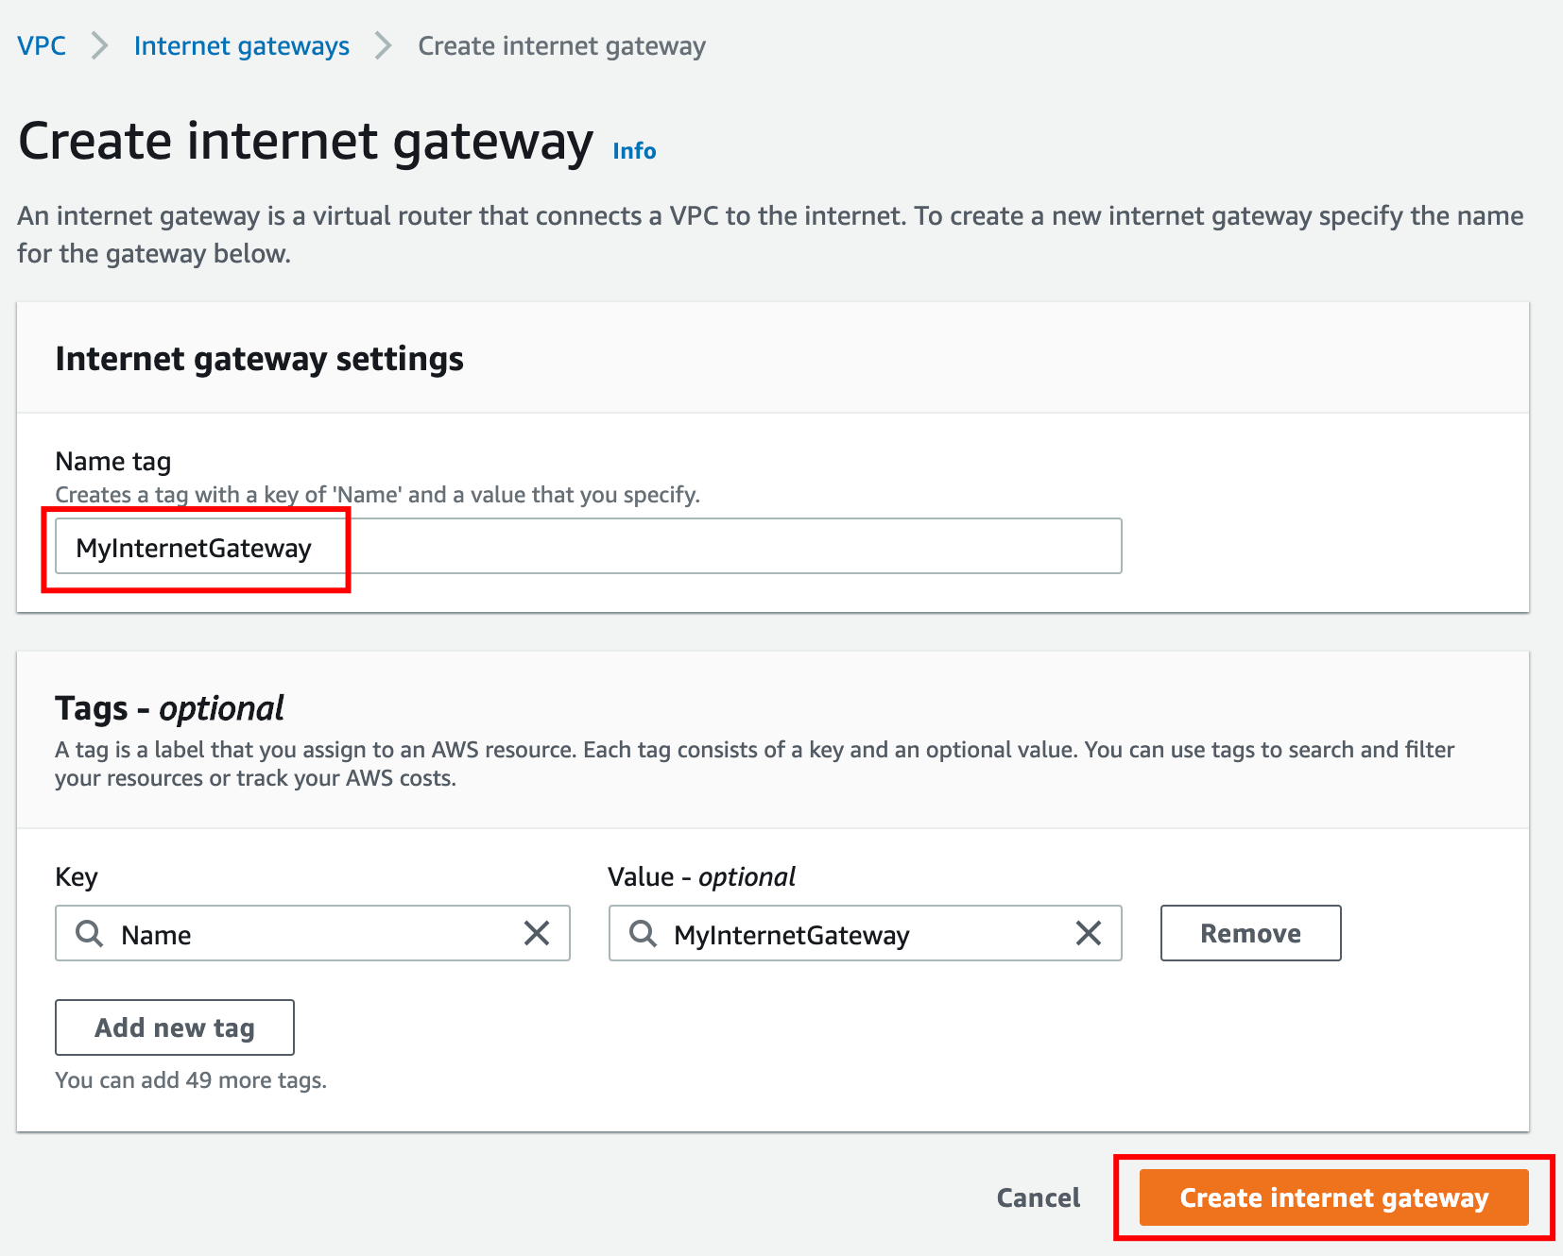
2. Select the Internet gateway you created from the list
   * Click on Actions.
   * Click on Attach to VPC.  
     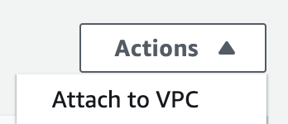
   * Select MyVPC which you created from the list and click on Attach internet gateway.  
     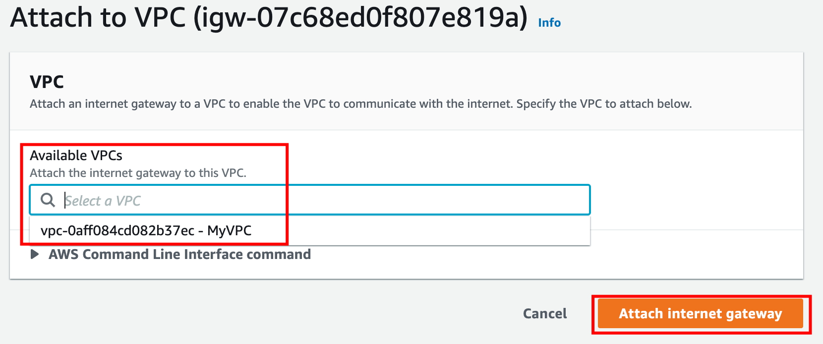

## Task 4 : Create Route Tables

1. Go to Route Tables from the left menu and click on 
   * Name Tag: Enter *PublicRouteTable*.
   * VPC: Select MyVPC from the list.
   * Click on Create route table.
2. Repeat the same steps to create a route table for the Private subnet.
   * Name Tag: Enter *PrivateRouteTable*.
   * VPC: Select MyVPC from the list.
   * Click on Create route table.

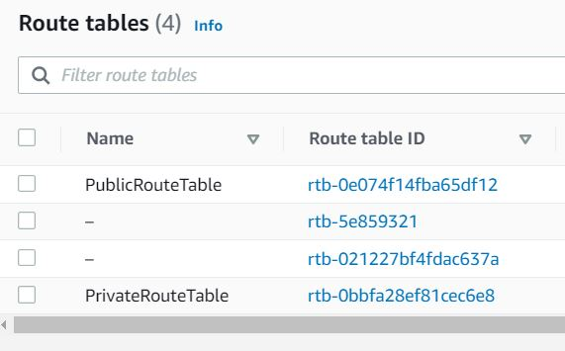

1. Now associate the subnets to the route tables.
2. Click on one PublicRouteTable and go to the Subnet Associations tab.
   * Click on Edit subnet associations.
   * Select MyPublicSubnet from the list.
   * Click on Save associations.
3. Click on one PrivateRouteTable and go to the Subnet Associations tab.
   * Click on Edit subnet associations.
   * Select MyPrivateSubnet from the list.
   * Click on Save associations.
4. Make sure not to associate any subnets with the Main Route Table.
5. PublicRouteTable: Add a route to allow Internet traffic to the VPC.
   * Select PublicRouteTable.
   * Go to Routes tab, click on Edit routes and on the next page, click on Add route.
   * Specify the following values:
     + Destination: Enter *0.0.0.0/0*
     + Target: Select Internet Gateway from the dropdown menu to select MyInternetGateway.
     + Click on Save changes.